**REG NO : 19BCS0012**

**NAME : NITHISH G**

**COURSE CODE : CSC3004**

**COURSE : VISUAL PROGRAMMING**

**DATE : 19.02.2021**

**AIM**

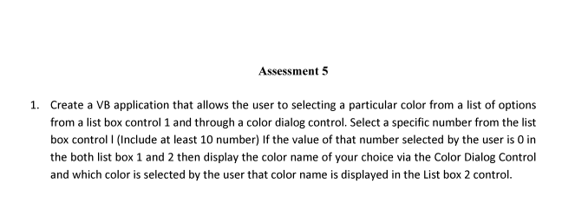

**DESIGN FORM**

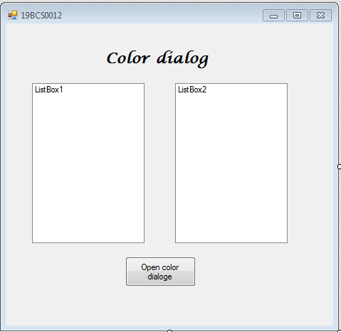

**Source Code**

Public Class Form1

Private Sub Form1_Load(ByVal sender As System.Object, ByVal e As System.EventArgs) Handles MyBase.Load

ListBox1.Items.Add(0)

ListBox1.Items.Add(1)

ListBox1.Items.Add(2)

ListBox1.Items.Add(3)

ListBox1.Items.Add(4)

ListBox1.Items.Add(5)

ListBox1.Items.Add(6)

ListBox1.Items.Add(7)

ListBox1.Items.Add(8)

ListBox1.Items.Add(9)

ListBox1.Items.Add(10)

ListBox2.Items.Add(0)

ListBox2.Items.Add(1)

ListBox2.Items.Add(2)

ListBox2.Items.Add(3)

ListBox2.Items.Add(4)

ListBox2.Items.Add(5)

ListBox2.Items.Add(6)

ListBox2.Items.Add(7)

ListBox2.Items.Add(8)

ListBox2.Items.Add(9)

ListBox2.Items.Add(10)

End Sub

Private Sub Button1_Click(ByVal sender As System.Object, ByVal e As System.EventArgs) Handles Button1.Click

If ListBox1.SelectedItem.Equals(ListBox2.SelectedItem) Then

ColorDialog1.ShowDialog()

Dim index As Integer = ListBox2.SelectedIndex

ListBox2.Items.RemoveAt(index)

ListBox2.Items.Insert(index, ColorDialog1.Color)

End If

End Sub

End Class

**Output**

